**Testing Functional Document**

**ToDo List Rest API using C#.NET Core**

In Visual Studio 2022 Click Start Without Debugging (Ctrl-F5) :

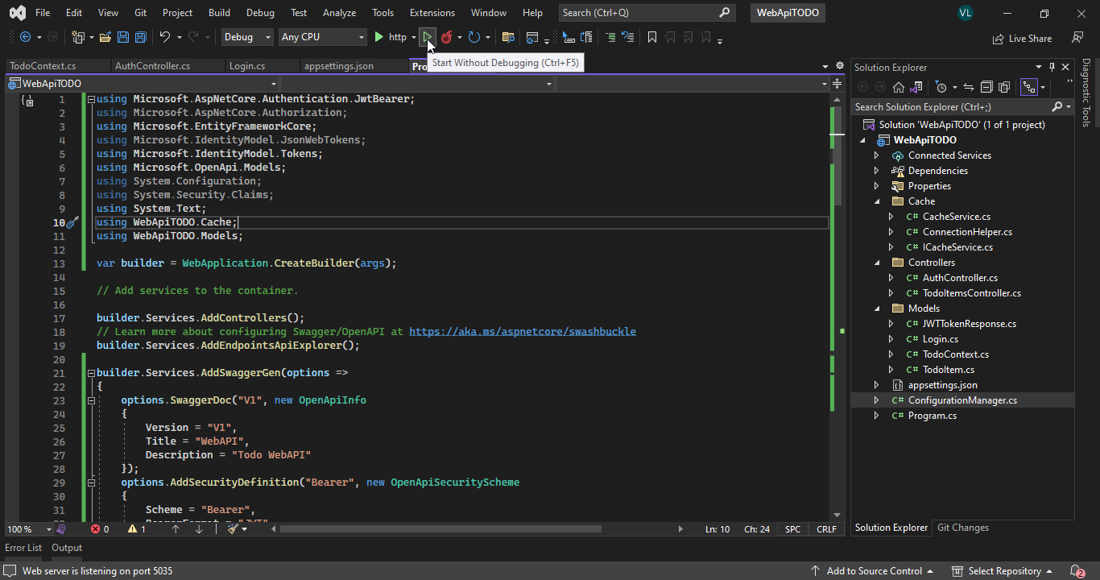

After that it can be see in the browser like picture below :

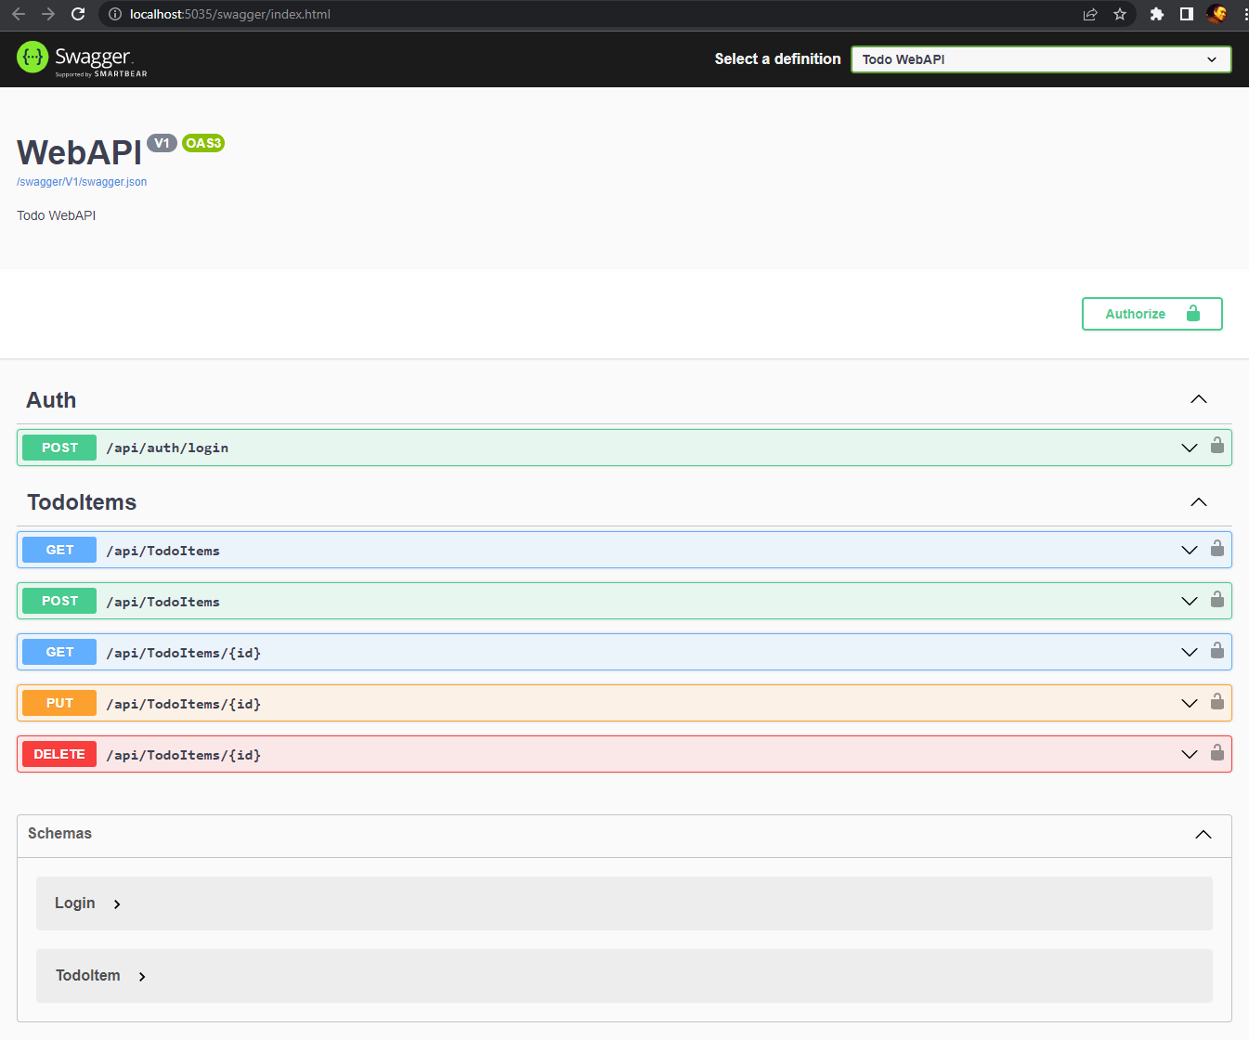

To test the API first we must enter the login :



After click right “V” position then show below : Next click Try it out

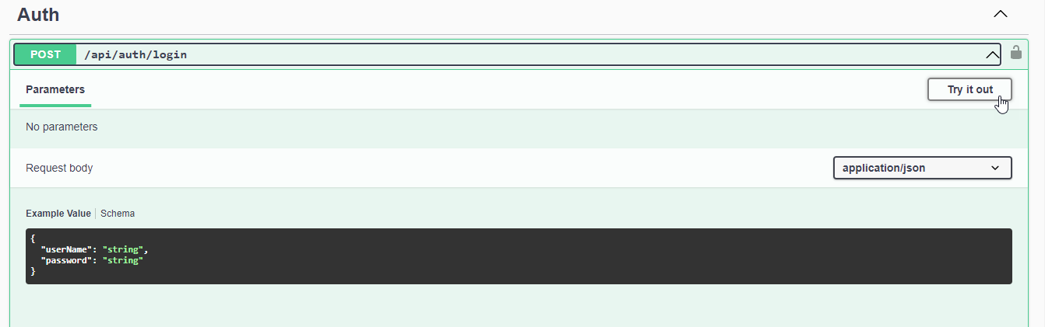

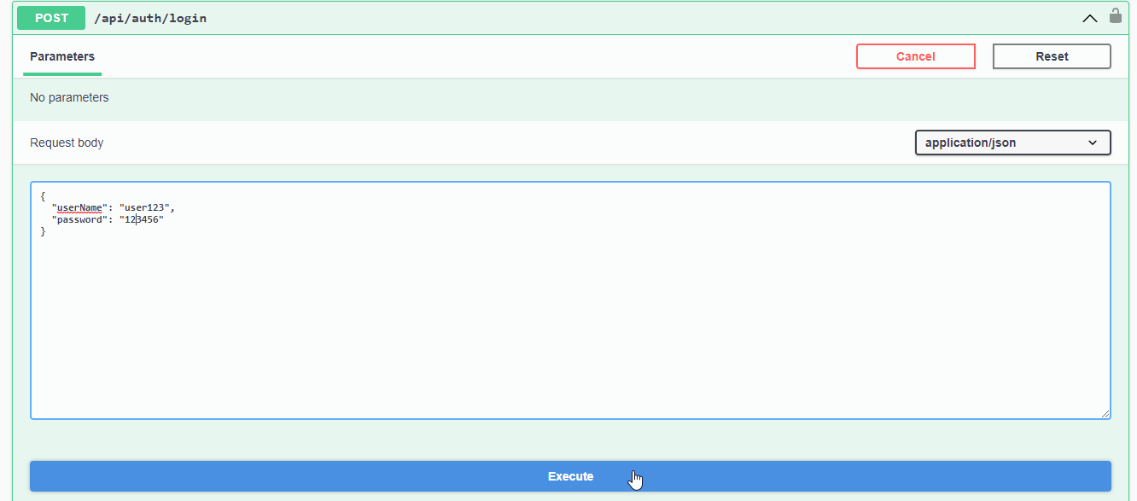After click Try it out : Then fill the UserName = user123 and Password = 123456 and then click Execute button (blue)

After click Execute button : Then Token will be generated. Copy the token

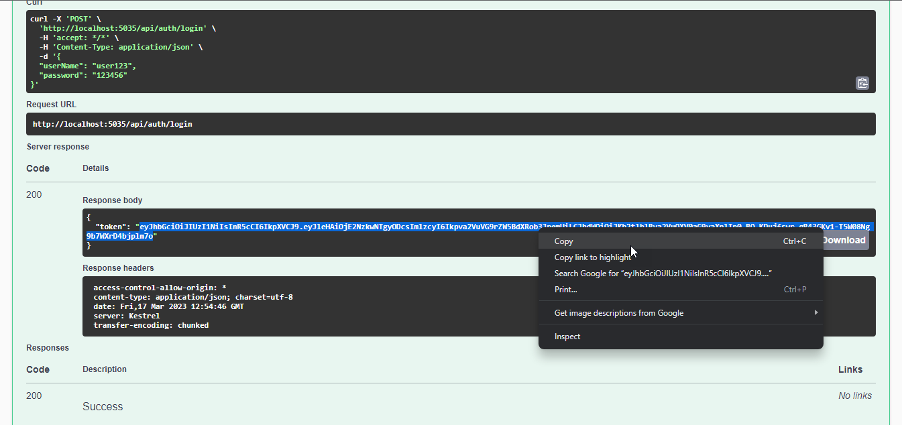

Click Authorize button on top of page.

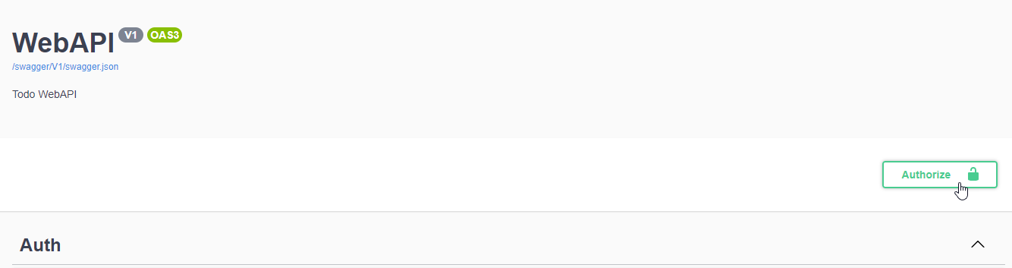

After that it will show popup form like form below : Paste then token inside textbox and then click Authorize button

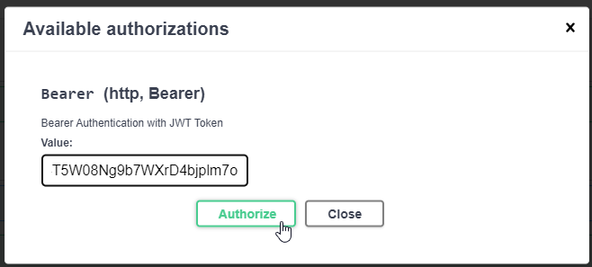

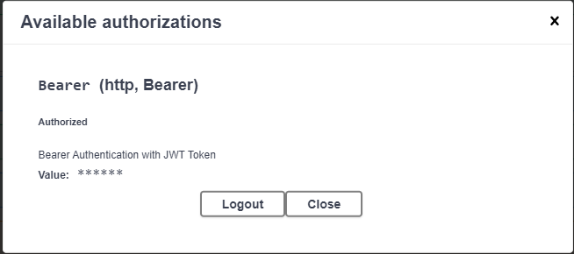Here the result after click authorize :

Now we already authorized and then can be call the rest of API function :

